WEB API (Application Programming Interface)
Web APIs are HTTP-based services that can be accessed from a browser or mobile apps.
It is a tool that can be used to push data to a server and can be accessed by server code.
A Web API (Application Programming Interface) is a set of rules and definitions that allow different software applications to communicate with each other over the internet.

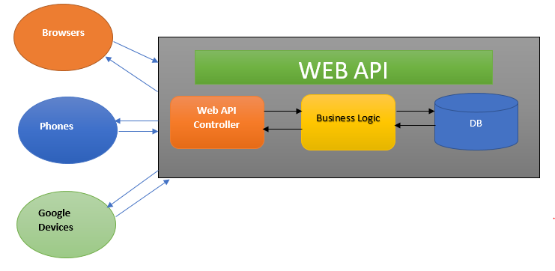
Web API advantages over WCF and Web services
Srno | WCF | Web api
1 | It is not open-source software | Web api is an open source and also ships with the .NET Framework
2 | It depends on the attributes based on the programming model. | Web API maps verbs to methods, i.e., HTTP (get, post, put, and delete)
3 | WCF offers support for a limited RESTFUL service. | Web Api is ideal for building a RESTful service.

It works the way HTTP works using standard HTTP verbs like GET, POST, PUT, delete for all the crud operation.
It is an open source.
It is a lightweight architecture and is good for devices that have limited bandwidth.
Web api controller pattern is very similar to the MVC controller; thus, it becomes easy to maintain and understand
Web Api has very easy configuration settings compared to WCF.

HTTP verbs or HTTP methods

HTTP methods, also called HTTP verbs, define the actions a client requests on a server resource in web communication. They form the core of HTTP's uniform interface, enabling operations like retrieving or modifying data.

HTTP method | Action
GET | Obtain Information about the resources
GET | Obtain Information about the resources.
POST | Create a new resource.
PUT | Update a resource
DELETE | Delete a resource

What is REST and RESTful

Is it possible to use WCF as RESTful services?
- Yes, we can develop RESTful services with WCF.

How to consume a Web API from a .NET MVC application?

